Steps 1 : Copy msi file in server:

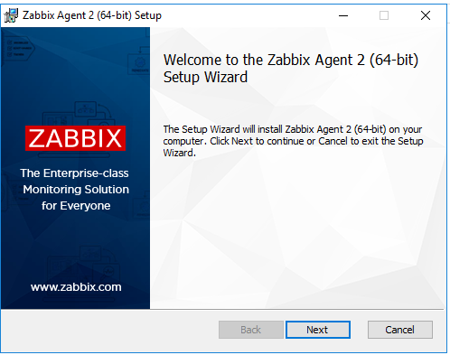

Step 2: Click Next

Step 3: In next screen Accept Agreement and click Next

Step 4: Add Zabbix Proxy Server Ip address 10.10.105.137 in two place (Zabbix Server IP /DNS) and Proxy Server for Active check. In next screen as per below screenshot

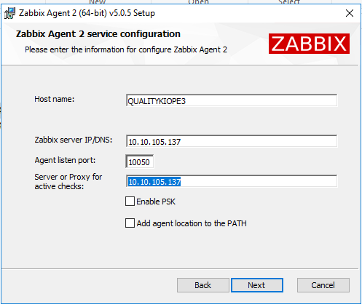

Step 5: Click Next in next screen

Step 6: Click Install next screen as per below screenshot.

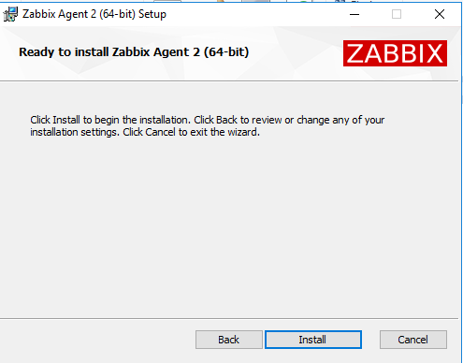

Step 7: After Install is complete just click Finish.

Step 8: Please Update confluence page ip address of server in which agent is installed.

Will do host configuration in Zabbix server for client server in which agent installation is complete.

Zabbix agent 2 installation in Linux

***Ubuntu Servers***

Zabbix 5.0 LTS version (supported until May 31, 2025)

sudo wget https://repo.zabbix.com/zabbix/5.0/ubuntu/pool/main/z/zabbix-release/zabbix-release_5.0-1+$(lsb_release -sc)_all.deb

sudo dpkg -i zabbix-release_5.0-1+$(lsb_release -sc)_all.deb

sudo apt -y install zabbix-agent

***Redhat/ CentOS Server***

Zabbix 5.0 LTS version (supported until May 31, 2025)

rpm -Uvh https://repo.zabbix.com/zabbix/5.0/rhel/$(rpm -E %{rhel})/x86_64/zabbix-release-5.0-1.el$(rpm -E %{rhel}).noarch.rpm

yum -y install zabbix-agent

***After yum install.***

*vi /etc/zabbix/zabbix_agentd.conf*

***And make below changes***

**# Remove 127.0.0.1 and add 10.10.105.137**

Server=10.10.105.137

**# Remove 127.0.0.1 and add 10.10.105.137**

ServerActive=10.10.105.137

**#Uncomment and add hostname of server**

Hostname=ingredispg

**#Uncomment and add release**

HostMetadata=release

**#Uncomment and add below line**

UserParameter=release,cat /etc/redhat-release

systemctl start zabbix-agent2.service